MONICA SUN  Beijing,Shanghai  Partner·Singapore  +86 10 5769 5613 / +86 21 2208 1178 / +86 1511 695 7877  monica.sun@fangdalaw.com | 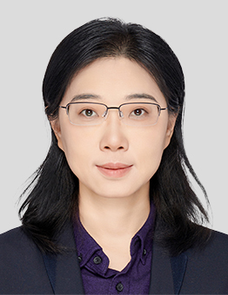
PRACTICE AREAS
MONICA HAS 20 YEARS OF PROFESSIONAL EXPERIENCE AND PROFOUND EXPERTISE IN POWER, OIL AND GAS, AND INFRASTRUCTURE. HER PRACTICE FOCUSES ON MERGERS AND ACQUISITIONS, JOINT VENTURES, PROJECT DEVELOPMENT AND FINANCING, PRIVATE EQUITY INVESTMENTS, CORPORATE AFFAIRS, AND CORPORATE FINANCING.

Since 2004, Ms. Sun has been involved in overseas LNG procurement projects for Chinese companies, providing legal services to Chinese buyers on a wide range of issues including LNG purchase and sale, LNG project investment and development, LNG asset mergers and acquisitions, LNG liquefaction and processing arrangements, and the operation of LNG receiving terminals, with extremely rich experience.
REPRESENTATIVE MATTERS AND CASES
Education
- Peking University Law School, Bachelor of Laws, 2000
- Peking University Law School, Master of Laws, 2002
- University College London (UCL), Master of Laws, 2003
- Harvard University, Master of Laws (LLM), 2008
Professional Qualification
- Legal Professional Qualification of the PRC
- Admitted to practice in New York
Work Language
- Mandarin (Native)
- English (Fluent)
Professional Background
- Before joining Fangda Partners, Ms. Sun worked at a well-known international law firm, serving as the managing partner in charge of China's energy practice.
OTHER INFORMATION
Honors and Awards
- China: Energy & Natural Resources - Band 1 (Chambers Greater China 2022-2024)
- China: Projects & Energy - Hall of Fame (The Legal 500 Asia Pacific 2023-2024)
- China: Leading Lawyer in Energy & Natural Resources (Chambers Asia-Pacific 2017-2021)
- China: Leading Lawyer in Projects & Infrastructure (Chambers Asia-Pacific 2020-2023)
- China: Leading Lawyer in Projects & Energy (The Legal 500 Asia Pacific 2018-2022)

