CLAIRE KOU  Counsel·Beijing  +86 10 5900 7453  claire.kou@fangdalaw.com | 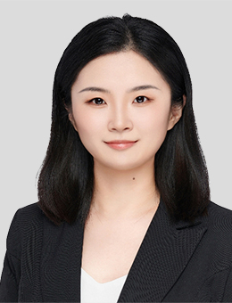
PRACTICE AREAS
MS. CLAIRE KOU SPECIALIZES IN INVESTMENT FUNDS, PRIVATE EQUITY AND INVESTMENT MANAGEMENT.

REPRESENTATIVE MATTERS AND CASES

- Represented Oaktree Capital in forming its Shanghai QDLP fund
- Represented Coller Capital in forming its first RMB secondary fund
- Represented L Catterton in forming its first RMB fund
- Represented Jinyi Capital in forming several RMB funds
- Represented Visionstone in forming its first RMB fund
- Represented Cainiao in forming an RMB fund co-sponsored by Cainiao and China Life
- Represented CICC Capital in forming several RMB funds
- Represented Everbright in forming several RMB funds
- Represented Ant Group in its investments in several RMB funds
Education
- Nanjing University, LL.B., 2013
- China University of Political Science and Law, LL.M., 2016
Professional Qualification
- Admitted to practice in the PRC
Professional Background
- Ms. Kou joined Fangda in 2019. Prior to joining the firm, Ms. Kou worked at a leading PRC law firm in its Beijing office.

