KAI WANG  Beijing  +86 10 5769 5728  kai.wang@fangdalaw.com | 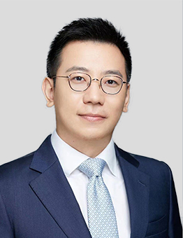
PRACTICE AREAS
MR. WANG’S PRACTICE FOCUSES MAINLY ON M&A, PRIVATE EQUITY INVESTMENT AND GENERAL CORPORATE MATTERS.

REPRESENTATIVE MATTERS AND CASES
M&A
- Represented KKR in its acquisition of NVC Lighting
- Represented Asiainfo Technologies Limited (1675.HK) in its acquisition of iResearch
- Represented Metito in its proposed acquisition of a wastewater treatment plant
- Represented Kuaishou in its proposed acquisition of an online video streaming company
- Represented China Huaneng in its acquisition of multiple photovoltaic power plants from GCL
- Represented multiple international exhibition companies in their acquisition of Chinese exhibitions
- Represented Bytedance in its acquisition of an online English education company
- Represented China Orient Qianhai Asset Management in its proposed acquisition of a hydropower plant
Private Equity and Financing
- Represented Boyu, Affinity Equity Partners, CPE and other private equity funds in their equity investments in pre-IPO companies
- Represented IDG, SIG, Matrix, NIO Capital, Kinzon Capital, HUAGAI Capital, China Venture Capital, K2, NLVC and other venture capital funds in their equity investments in multiple startups
- Represented Taikang Insurance and Sunshine Insurance in their equity investments in multiple startups
- Represented Huangbaoche, Merrymemo, Momenta, XYZ Robotics, Daishu and other startups in their equity financings
General Corporate and Restructuring
- Represented Alibaba in forming a joint venture with Accenture
- Represented Moviebook in its pre-IPO offshore restructuring
- Represented Daishu in its pre-IPO de-VIE restructuring
- Represented a US software company in spinning off its China business and financing
- Represented a state-owned electric appliance manufacturer in its reorganization and A-share listing
Education
- University of Wisconsin, Madison, J.D.
- Chicago-Kent College of Law, LL.M.
- East China University of Political Science and Law, LL.B.
Professional Qualification
- Admitted to practice in the State of New York
- Admitted to practice in the State of Wisconsin
Professional Background
- Before joining Fangda Partners in 2017, Mr. Wang worked for well-known PRC law firm for a year and a half and a US law firm for one year.

