ALICE PING  Counsel·Shanghai  +86 21 2208 1154  alice.ping@fangdalaw.com | 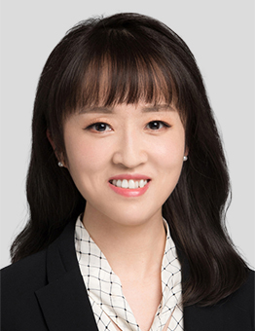
PRACTICE AREAS
ALICE PING SPECIALIZES IN PRIVATE EQUITY AND VENTURE CAPITAL INVESTMENT, CROSS-BORDER RESTRUCTURING, M&A AND GENERAL CORPORATE MATTERS.

REPRESENTATIVE MATTERS AND CASES

- Represented GGV Capital in its equity investments in enterprises such as MSENERGY, MegaRobo, CurrentCAD, Lanhu, Cloudbox, Today Camera, BUD APP and Blacklake and in its cross-border restructuring of target companies
- Represented Lilly Asia Ventures in its equity investment in a new drug R&D enterprise
- Represented Amphastar Pharmaceuticals in its CMO and CRO matters
- Represented a Japanese pharmaceutical R&D company in its drug licensing matter
- Represented CDB Investment Fund in its equity investment in an AR product manufacturing and service company
- Represented Yunfeng Capital in its equity investment in Xingyun Group, Nreal and two enterprises in consumer-goods industry
- Represented Ant Financial in its equity investment in Hellobike and in its cross-border restructuring of Hellobike
- Represented Ant Financial in its investment in a strategic joint venture with Hellobike and CATL
- Represented Ant Financial in its equity investment in E-INV, a subsidiary of an A-share listed company
- Represented Alibaba in its investment in Carzone Auto Parts and in its cross-border restructuring of Carzone
- Represented Sinopharm Capital in its equity investment in Virogin Biotech
- Represented Sinopharm Capital in its equity investment in Creative Biosciences
- Represented JAFCO in its equity investment in Palfish
- Represented AIF Capital in its equity investments in Aosheng Tech and in its cross-border restructuring of Aosheng
- Represented ClickPaas in its equity financing and its acquisition of Bplead
- Represented MitrAssist in its equity financing and post-closing matters
- Represented Panda ABC in its equity financing
- Represented Laifu Harmonic Machinery in its equity financings
- Represented an enterprise in fashion industry in its red-chip restructuring
- Represented Sodexo group in its acquisition of two catering service enterprises in China and a medical equipment management service enterprise in China
- Represented Sodexo group in its strategic investment in Meican
- Represented City Development Limited in its acquisition of Chongqing Sincere
- Represented Bunzl Plc in its acquisition of a Chinese enterprise distributing personal protection equipment
Education
- East China University of Political Science and Law, LL.M.
- East China University of Political Science and Law, LL.B.
Professional Qualification
- Admitted to practice in the PRC
- Admitted to practice in the State of California
Professional Background
- Alice Ping joined Fangda Partners in 2015.

