ZHANGXIAN CHEN  Counsel·Beijing  +86 10 5769 4281  zhangxian.chen@fangdalaw.com | 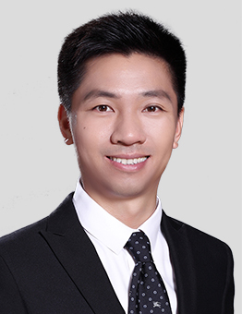
PRACTICE AREAS
ZHANGXIAN CHEN SPECIALIZES IN FOREIGN DIRECT INVESTMENT, M&A, RESTRUCTURING, SECURITIES OFFERING AND LISTING, AND GENERAL CORPORATE MATTERS.

REPRESENTATIVE MATTERS AND CASES

- Advised Gambol Pet Group (SZ301498) on its Series B Financing and it’s successful A share IPO on the ChiNext board of the Shenzhen Stock Exchange;
- Advised XPENG Inc. (NYSE: XPEV and HKEX: 9868-W) on its strategic partnership with Didi Global Inc., upon which, XPENG issues shares to DiDi and acquires the assets and R&D capabilities related to DiDi's Smart EV project;
- Advised KKR on its investments in the PRC assets of NVC Lighting, Adopt A Cow, Gambol Pet Group, Yuehai Feeds, Jiangsu Yuguan, Centrin Huaqiao Data Center and some other projects;
- Advised DCP Capital on its investments in Datong Insurance, Hotwon Group, Adopt A Cow, Jiuyue Hospital Management Group and some other companies;
- Advised China Reform Venture Capital on its investments in Huafeng Test & Control (SH688200) and Xidi Microelectronics (SH688173);
- Advised Morgan Stanley on its investments in One & Only Medical Cosmetology Group, Yancheng Haipurun Membrane Technology Co., Ltd. and some other companies;
- Advised CMC Capital on its investments in KK Group, LAIX (a NASDAQ-listed company), Daylight Entertainment and some other companies;
- Advised KKR, DCP Capital, Haitong International, Morgan Stanley and some other investors on their investments in a series of Data Center Projects in mainland China;
- Advised SoReal Culture Group on its Series Pre-A to Series C Financing, Red-Chip structure and general operation matters;
- Acted as the Sponsor’s PRC counsel in the IPO on SEHK by COFCO Meat (01610), Regina Miracle (02199), Zhongliang Womai and some other real estate companies.
Education
- China University of Political Science and Law, LL.M.
- China University of Political Science and Law, LL.B.
Professional Qualification
- Admitted to practice in the PRC
Professional Background
- Zhangxian Chen joined Fangda in 2015.

