ZHUAN JIANG  Partner·Beijing  +86 10 5769 4209  zhuan.jiang@fangdalaw.com | 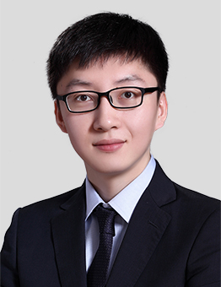
PRACTICE AREAS
MR. JIANG SPECIALIZES IN ASSETS MANAGEMENT, CAPITAL MARKETS AND GENERAL CORPORATE.

REPRESENTATIVE MATTERS AND CASES

- Represented Ant Finance, CSCEC, MCC, CEC, CICC, CMS, Sinolink Securities, China Unicom, CFLD, Qudian, Lakala, CCCC, China National Medical Device, CR Pharm and Sunshine 100 in their ABS on receivables
- Represented Ping An Asset Management, Taikang Asset Management, Zhongyi Asset Management, CITIC Prudential and other asset management institutions in their investment projects
- Represented CITICHMC in its acquisition and restructuring of Tangshan Kaicheng
- Represented SGGF in its acquisition and restructuring of Jingtang Steel
- Represented Alibaba, CITICPE, and Founder in their investment projects
Education
- China University of Political Science and Law, LL.B
Professional Qualification
- Admitted to practice in the PRC
Professional Background
- Mr. Jiang joined the firm in 2015. Before joining the firm, he worked at a reputable Chinese law firm for three years.

