WILLIAM HUANG  Partner·Shanghai  +86 21 2208 1001  whuang@fangdalaw.com | 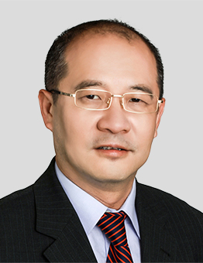
PRACTICE AREAS
MR. HUANG SPECIALIZES IN CORPORATE FINANCE AND BANKING.

Mr. Huang has great experience in corporate finance, general banking, in particular in syndication loans, company restructure, mergers and acquisition, listing in domesticoverseas stock exchanges for PRC companies.
REPRESENTATIVE MATTERS AND CASES
Education
- Law School of Shanghai Maritime University, LL.B
- Southeast Normal University, Shanghai, Master of Economics
Professional Qualification
- Admitted to practice in the PRC
Professional Background
- Mr. Huang is a founding partner of the firm.

