SHANJIAN ZHENG  Of Counsel·Shanghai  +86 21 2208 1166  shanjian.zheng@fangdalaw.com | 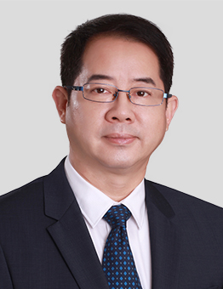
PRACTICE AREAS
MR. ZHENG SPECIALISES IN CRIMINAL INVESTIGATIONS AND CRIMINAL DEFENSE WORK, COOPERATE CRIMINAL RISK PREVENTION, CRISIS MANAGEMENT, AND COMMERCIAL DISPUTE RESOLUTION.

REPRESENTATIVE MATTERS AND CASES

- Represented a world leading entertainment technology company in a criminal investigation by the Customs relating to alleged evasion of customs duties.
- Represented multiple clients engaging in the importation and exportation business in the criminal proceedings (investigation, prosecution and trial) involving smuggling, and successfully assisted some clients to receive lenient treatments.
- Advised an investment company on the handing of a malicious report against the company regarding bribery, tax evasion, and smuggling and developed a mitigation strategy for criminal legal exposure to the company and its senior executives.
- Represented and defended a famous sanitary products manufacturer regarding the accused environmental pollution.
- Defended the legal representative of a private investment company in a criminal proceeding on sub-lending at excessive interest.
- Advised a US-headquartered hedge fund on a criminal charge regarding securities market manipulation.
- Represented a securities company in multiple entrusted investment contract disputes, including incidents relating to the handling of customer complaints and advised on strategies for risk mitigation of criminal charges against senior executives.
- Represented a Chinese subsidiary of a major international power company in an administrative investigation regarding violation of environmental protection laws and assisted the company in implementing remedial measures to prevent an escalation of the case into a criminal investigation.
- Acted for a Japanese-invested company on report to the police and assisted on criminal investigation procedures regarding suspected embezzlement and commercial bribery involving its senior executives.
- Acted for a Chinese private investment company on a criminal investigation procedure against a counterparty involving falsification of company seal and legal representative’s signature as part of the defense strategy in a high-stake civil litigation.
- Represented the legal representative of a private company in a criminal proceeding (investigation, prosecution and trial) regarding the falsification of VAT invoices.
- Advised a listed company on alleged insider trading by senior executives of a newly acquired company.
- Represented a trading company in a steel trading dispute, initiated both civil actions and criminal investigations in order to prevent hundreds of millions of dollars in losses.
- Over ten years’ experience advising multiple banks and real estate companies on matters related criminal investigations, criminal law risk prevention and crisis management.
Education
- East China University of Political Science and Law (Shanghai), LL.B
- University of Technology Sydney (offshore), LL.M
Professional Qualification
- Admitted to practice in the PRC
Professional Background
- Prior to practicing as an attorney, Mr. Zheng worked in the Shanghai court system for over fourteen years. Before joining Fangda Partners, Mr. Zheng spent for a total of seventeen years with two law firms as a partner and the deputy director. Mr. Zheng is a highly recognized criminal defense lawyer in China and has extensive experience in representing multinational companies.

