JOYCE HUANG  Partner·Shanghai  +86 21 2208 1092  Joyce.huang@fangdalaw.com | 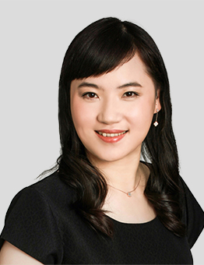
PRACTICE AREAS
MS. HUANG SPECIALIZES IN BANKRUPTCY AND RESTRUCTURING, COMMERCIAL LITIGATION AND ARBITRATION, AND FAMILY LAW.

REPRESENTATIVE MATTERS AND CASES
Bankruptcy and Restructuring
- Acted as the administrator of Tian Hai Fang Wu, a listed company in Shanghai with several billion in assets and debts
- Acted as the administrator of Zhou Xian Real Estate Co., a company with several billion in assets and debts
- Acted as the joint administrator of a group company with over 100 billion in assets and debts
- Represented the creditors’ committee in the restructuring of Yurun
- Represented the creditors’ committee in the restructuring of Sanpower Group
- Represented the creditors’ committee in the restructuring of Fullshare
- Represented China Cinda as the investor in the restructuring of a listed company in Qinghai
- Represented China Cinda as the investor in the restructuring of 29 companies in Shandong
- Represented American Industrial Partners as the investor in a bankruptcy restructuring case in Shandong
- Acted as the joint administrator of Huaxin Group, a company with several billion in assets and debts
- Represented Korean banks in a creditor’s right dispute with STX (Dalian)
- Represented Tiantian Logistics in its restructuring
- Represented China Orient as the investor in various bankruptcy restructuring cases
- Advised several foreign invested companies on their liquidation matters
Commerical Litigation and Arbitration Cases
- Represented foreign banks in loan dispute litigation
- Represented The Royal Bank of Scotland Group in a finance leasing dispute
- Represented Thermo Fisher Scientific in supply and a trade secret litigation
- Represented US Smartwool Corporation in a product quality litigation
- Represented Honeywell in arbitration over a supply dispute
- Represented I.T China in arbitration over a lease dispute
- Represented a UK company in an international trade dispute
- Represented a Beijing company in arbitration over a share transfer dispute
- Represented Zegna China in consignment agreement litigation
- Represented Ermenegildo Zegna in a share transfer dispute
Family Law
- Advised a shareholder on pre-marital property arrangements and drafted a prenuptial agreement
- Advised on the division of shareholdings and debts and drafted a divorce agreement
- Advised on estate disposal schemes and drafted a will
- Represented a client in conducting foreign-related inheritance notarizations
- Represented clients in inheritance lawsuits
- Represented clients in divorce lawsuits
- Advised on shareholding inheritance plans to prevent share dilution from divorce and inheritance
- Designed wealth inheritance plans for high-net-worth individuals
Education
- Bristol University of the UK, LL.M
- Shanghai International Studies University, LL.B
- Shanghai University of Finance and Economics, Accounting Diploma
Professional Qualification
- Admitted to practice in the PRC
Professional Background
- Ms. Huang joined Fangda in 2008.

