ARNOLD PANG  Partner·Hong Kong  +852 3976 8890  arnold.pang@fangdalaw.com | 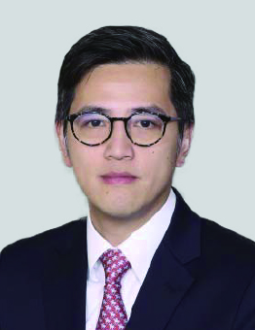
PRACTICE AREAS
MR. PANG SPECIALIZES IN EQUITY CAPITAL MARKETS, FOREIGN INVESTMENT, CORPORATE GOVERNANCE AND COMPLIANCE MATTERS, AS WELL AS M&A WORK.

REPRESENTATIVE MATTERS AND CASES

- Advised Sun Car Insurance Agency Co., Ltd. (stock code: 1879) on its proposed US$168 million H-shares global offering and listing on the Main Board of the Hong Kong Stock Exchange. Sun Car was quoted on the NEEQ and sought for dual listing of its H shares on the Hong Kong Stock Exchange. The joint sponsors were China Galaxy International and CICC
- Advised Haitong International as one of the underwriters on a HK$1.9 billion rights issue of Carnival Group International Holdings Limited (stock code: 996)
- Advised Genscript Biotech Corporation in a US$60 million global offering and listing of its shares on the Main Board of the Hong Kong Stock Exchange. The Sponsor was Haitong International
- Advised Haitong International as one of the underwriters on a HK$340 million rights issue of GR Properties Limited (stock code: 108)
- Advised Fu Shou Yuan International Group Limited in a US$200 million global offering and listing of its shares on the Main Board of the Hong Kong Stock Exchange. The underwriters were Citigroup, UBS and CIMB
- Advised BOC International, China Merchants Securities, China Securities, Macquarie Capital Securities in a HK$900 million global offering of Wisdom Holdings Group and listing of its shares on the Main Board of the Hong Kong Stock Exchange
- Advised Melco Crown Entertainment Limited on its listing by way of introduction on the Main Board of the Hong Kong Stock Exchange. The sponsors were Credit Swiss and Deutsche Bank
- Advised CICC, Goldman Sachs, J.P. Morgan, Morgan Stanley, BOCI and Credit Suisse in the HK$13 billion global offering of Changsha Zoomlion Heavy Industry Science and Technology Development Co., Ltd. and in the listing of its shares on the Main Board of the Hong Kong Stock Exchange
- Advised BaWang International (Group) Holding Limited in a HK$1.6 billion global offering and listing of its shares on the Main Board of the Hong Kong Stock Exchange. The underwriters were HSBC and Morgan Stanley
- Advised Fosun International Limited in a US$11.5 billion global offering and listing of its shares on the Main Board of the Hong Kong Stock Exchange. The underwriters were Morgan Stanley, UBS and CICC
Education
- University of Toronto, B.A.
- The University of Hong Kong, LL.B
- The University of Hong Kong, PCLL
Professional Qualification
- Admitted to practice in Hong Kong SAR
Professional Background
- Before joining Fangda Partners, Mr. Pang worked at two prominent international firms, Shearman & Sterling and Herbert Smith Freehills.

