AMANDA ZHOU  Beijing  Hong Kong  +86 136 0139 1203 | +852 6274 8166  amanda.zhou@fangdalaw.com | 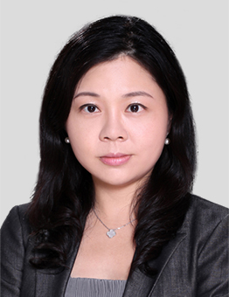
PRACTICE AREAS
MS. ZHOU HAS EXTENSIVE EXPERIENCE IN GENERAL CORPORATE FINANCE AREAS, INCLUDING PRIVATE EQUITY AND VENTURE CAPITAL INVESTMENTS, M&A, AND FOREIGN DIRECT INVESTMENT.

REPRESENTATIVE MATTERS AND CASES

- Represented Anjuke.com in the acquisition of Anjuke by 58.com
- Represented Bytedance in its multiple rounds of financing for industry investment and acquisitions
- Represented Mobvoi in its multiple rounds of financing by Goertek, Google Inc. and Volkswagen and industry acquisition
- Represented musical.ly in its multiple rounds of financing in its merger with Bytedance
- Represented Huangbaoche, in its multiple rounds of financing and industry acquisition
- Represented Rong360 in its multiple rounds of financing, restructuring, IPO and industry acquisition
- Represented Belle in its industry acquisition
- Represented MarryMemo in its Series C and D rounds of financing
- Represented AI Education in its Series B round of financing
- Represented IDG in its financing of Opay, an online payment business operator
- Represented Alibaba in its financing in Meituan, 36Kr, Yummy, etc
- Represented Softbank Vision Fund, IDG, LightSpeed, Matrix, SIG, Sequoia, Hillhouse, Innovation Works, Meridian Capital, Pavilion Capital, Kinzon, NLVC, VKC, Eastern Bell Capital, Shunwei Capital, Source Code, Banyan Capital, BAI, Invention Capital, ZhenFund, Nio Capital, GLP and HG Capital in their portfolio investments
Education
- Georgetown University Law Center, LL.M. with distinction
- Hamburg University Law School, LL.M
- China University of Political Science and Law, LL.B.
Professional Qualification
- Admitted to practice in New York
- Admitted to practice in the PRC
- Registered Foreign Lawyer in Hong Kong SAR
Professional Background
- Before joining Fangda Partners, Ms. Zhou worked in the Beijing office of a major Chinese law firm and two international law firms for over 10 years. She has also worked as general counsel of a leading venture capital firm.
OTHER INFORMATION
Ms. Zhou’s practice focuses on corporate and commercial matters. She advises clients on private equity and venture capital portfolio investments, M&A, foreign direct investment, project financing, and general corporate law matters.

