HELEN ZHAO  Counsel·Beijing  +86 10 5769 5666  helen.zhao@fangdalaw.com | 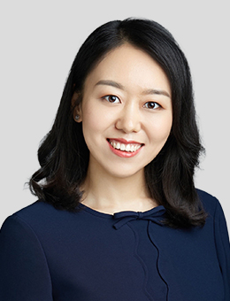
PRACTICE AREAS
MS. ZHAO SPECIALIZES IN CROSS-BORDER CAPITAL MARKET TRANSACTIONS (DEBT AND EQUITY OFFERINGS) AND PRIVATE EQUITY MATTERS.

REPRESENTATIVE MATTERS AND CASES
Debt and hybrid securities offerings
- Advised Asian Infrastructure Investment Bank, Asian Development Bank, Hungary, the Republic of the Philippines, BMW Group, Crédit Agricole S.A., Deutsche Bank and United Overseas Bank on their panda bond program registration and the issuances thereunder
- Advised Zhongyuan Asset Management, Henan Investment Group, Taizhou Xintai Group, Hangzhou Jianggan District Urban Construction & Comprehensive Development Co., Limited and Ningbo Yincheng Group on their USD bond offerings
- Advised underwriters on the panda bond program registration and the issuances thereunder of Cassa depositi e prestiti S.p.A., the Bank of Tokyo-Mitsubishi UFJ and Hang Lung Properties
- Advised underwriters on the USD bond offerings of Sinopec, Fosun, Nanjing Lishui City Construction Group and other PRC-based issuers
- Advised underwriters on the zero-coupon convertible bond offering by China Railway Construction Co., Ltd.
Equity offerings and listings
- Advised China International Capital Corporation on its H share IPO and listing
- Advised China Securities on its H share IPO and listing
- Advised China Cinda on its private placement of H shares to COSCO
- Advised an insurance group on its proposed Hong Kong IPO and listing
- Advised a financial leasing company in China on its proposed Hong Kong IPO and listing
Private equity and mergers & acquisitions
- Advised companies (such as UCar and XYZ Robotics) on their rounds of equity financings
- Advised Matrix Partners China, SAIF Partners, Legend Capital and Songhe Capital on the investment in target companies
- Advised ChipMOS on its acquisition and privatization of a NASDAQ listed company and its listing in NASDAQ after the acquisition
- Advised Shell on its joint venture project in China * Include matters completed prior to joining Fangda
Education
- New York University School of Law, LL.M
- The Chinese University of Hong Kong, LL.M
- Dalian Maritime University Law School, LL.B
Professional Qualification
- Admitted to practice in the PRC
- Admitted to practice in the State of New York
Professional Background
- Ms. Zhao joined Fangda in 2018. Before joining the firm, she ever worked at Davis Polk & Wardwell LLP in its Beijing office and King & Wood Mallesons.
- Ms. Zhao was ever nominated as a rising star in IFLR1000 Awards 2022 China shortlist and Legal 500 2022 Edition of Asia Pacific Rankings. Ms. Zhao was also recommended by “Legal 500” in the PRC capital markets for the year 2022.

