JEANETTE WANG  Partner·Beijing  +86 10 5769 5711  Jeanette.wang@fangdalaw.com | 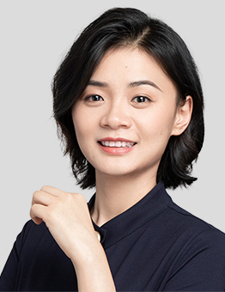
PRACTICE AREAS
MS. WANG SPECIALIZES IN INTELLECTUAL PROPERTY RELATED LITIGATION AND TRANSACTIONS AND IN ANTITRUST LITIGATION. SHE HAS EXTENSIVE EXPERIENCE IN REPRESENTING CLIENTS IN PATENT, COPYRIGHT, TRADEMARK, AND UNFAIR COMPETITION CASES. MS. WANG ALSO HAS EXTENSIVE EXPERIENCE REPRESENTING CLIENTS IN THE PHARMACEUTICAL, ELECTRONICS, AND TELECOMMUNICATION INDUSTRIES.

REPRESENTATIVE MATTERS AND CASES
Litigation Matters
- Represented a U.S. university in patent invalidation proceedings involving a chemical compound patent
- Represented a U.S. medical device company against domestic companies in patent infringement cases involving TTField treatment
- Represented a U.S. medical device company against domestic companies in patent infringement cases involving single molecule array analyzers
- Represented a Hong Kong-based patentee in patent cases involving noninvasive prenatal diagnostic technology
- Represented a Korean company in patent invalidation proceedings involving solar cell technology
- Represented VMware in an antitrust case filed by its former reseller for alleged abuse of market dominance
- Represented InterDigital in FRAND-related lawsuits filed by several implementers of InterDigital's telecommunication standards
- Represented a domestic cell phone manufacturer in an SEP-related patent infringement case
- Represented Apple against Qualcomm in patent invalidation and infringement lawsuits
- Represented General Electric in several patent infringement lawsuits concerning 3D technology
- Represented Apple and its affiliates in App Store lawsuits, including copyright, trademark and unfair competition disputes
Non-Litigation Matters
- Advised a Japanese pharmaceutical company on disputes arising from clinical trials
- Advised multiple international pharmaceutical companies on drug registration issues
- Advised New Horizon Health in its initial public offering and listing on the Hong Kong Stock Exchange
- Represented HTA in various in-licensing transactions with international and domestic pharmaceutical companies
- Advised multiple international and domestic pharmaceutical companies on FTO, patent validity analysis, etc.
- Advised various investors on IP due diligence work for target companies in the healthcare and biotechnology industries
Education
- Peking University School of Transnational Law, J.D.
- Peking University Health Science Center, M.D.
Professional Qualification
- Admitted to practice in the PRC
- Admitted to practice before SIPO
Professional Background
- Ms. Wang joined Fangda in 2015.

