SHENGJIE SHI  Partner·Shanghai  +86 21 2208 1166  shengjie.shi@fangdalaw.com | 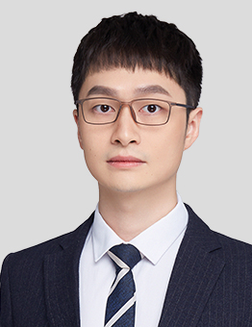
PRACTICE AREAS
MR. SHI SPECIALIZES IN PRIVATE EQUITY, VENTURE CAPITAL, M&A, STRUCTURED FINANCE, AND ASSET MANAGEMENT. HE IS ACTIVELY INVOLVED IN PROVIDING LEGAL SERVICES IN THE MEDIA, INTERNET, FINANCE AND TECHNOLOGY INDUSTRIES.

REPRESENTATIVE MATTERS AND CASES
M&A, PE AND REORGANIZATION
- Represented CMC Capital in TMT industry acquisitions, including acquisitions of Zilong Game and XuXuHuaSheng Media
- Represented KOUBEI in its buyout acquisition of MeiWei BuYongDeng, a leading smart catering service provider in China
- Represented Matrix Partners China in its TMT industry investments in China, including investments in GongYunWangLuo, BravoKids, YiGongTongZhi, QuickDecision, and Apiseven
- Represented Ant Group in its investments in a leading logistics information platform and in a leading outdoor advertisement company listed on the Hong Kong Stock Exchange
- Represented Hillhouse in its investment in Yincheng Technology, a leading commercial bill exchange platform
- Represented Sequoia in its investments in Woqu and Jiu Xiaoer
- Represented Alibaba in its investment in Xieyun Technology
- Represented Qianxun SI, a leading precise positioning service provider, in its financing from the series A investors of China Venture Capital, Shanghai International Group and ICBC
- Represented Jinyi Capital in its investment in Hongjiu Fruit, a leading fruit supplier
- Advised several TMT companies on their overseas red-chip reorganizations
- Advised on various corporate matters for TMT companies including Alibaba and Ant Financial
ABS Products
- Represented JIC Trust, Great Wall Securities, CSC, Macalline, Shanghai Trust, Tailong Bank, HSBC, Baoxin Leasing and other institutions in connection with their ABS products
Education
- East China University of Political Science and Law, LL.M.
- East China University of Political Science and Law, LL.B.
Professional Qualification
- Admitted to practice in the PRC
Professional Background
- Mr. Shi joined Fangda in 2018. Before joining the firm, he worked at another top-tier PRC law firm.

