RAY XU  Partner·Beijing  +86 10 5769 5704  ray.xu@fangdalaw.com | 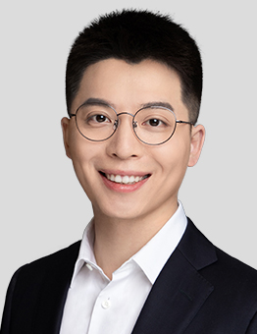
PRACTICE AREAS
MR. XU SPECIALIZES IN CORPORATE FINANCE, INCLUDING M&A, PRIVATE EQUITY INVESTMENT, CAPITAL MARKETS, AND GENERAL COMMERCIAL MATTERS.

REPRESENTATIVE MATTERS AND CASES
M&A AND PRIVATE EQUITY
- Represented Zoomlion in the sale of its environmental business
- Represented Primavera in various investment and exit deals, including investments in China and COSMX
- Represented KKR in its acquisition of NVC Lighting
- Represented CRHC in its acquisition of Dagong Credit
- Represented ChemChina in its acquisition of Syngenta
- Represented China IC Industry Investment Fund in its investment in various integrated circuit companies, including GOODIX
- Represented Taikang Insurance in various exit deals and outbound investments, including investments in funds managed by Blackstone and GLP
- Represented Ali Pictures in its acquisition of various theater chains
- Represented AEP in its acquisition of JML Food Co., Ltd. and Landseed hospital in Shanghai
- Represented CITIC Agriculture Fund in its investment in Molbreeding
- Represented China Orient Asset Management Co., Ltd in various domestic equity investment deals
CAPITAL MARKETS
- Representing sponsor CICC in connection with GAC Group’s private placement of A shares
- Represented Ant Group in its IPO on the STAR Board and the Hong Kong Stock Exchange
- Represented Alibaba in its IPO on the HKEX
- Represents Zoomlion in its private placement and various bond issuances
- Represented financial advisor CICC in connection with Minjiang Hydropower’s “stock for asset” deal with State Grid Information & Telecommunication Group
- Represented financial advisor CICC in connection with Yunan Baiyao’s reverse merger with its controlling shareholder
- Represented Blue Sail Co., Ltd. in its acquisition of Biosensors Group through a “stock for asset” deal
- Represented financial advisor CICC in connection with Shenhua Group’s merger with Guodian Group
- Represented Baosteel Co., Ltd. in its merger with Wuhan Steel Co., Ltd.
- Represented Wuxi AppTec Co. Ltd. in its domestic IPO
Education
- Peking University School of Law, LL.B. (2013) and LL.M. (2015)
- Peking University National School of Development, B.S. in Economics (2013)
Professional Qualification
- Admitted to practice in the PRC
Professional Background
- Mr. Xu joined Fangda in 2015.

