MICHAEL EDWARDS  Beijing  +86 10 5769 5684  michael.edwards@fangdalaw.com | 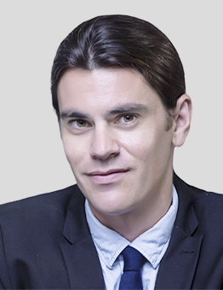
PRACTICE AREAS
MICHAEL’S PRACTICE FOCUSES ON INTERNATIONAL ARBITRATION.

REPRESENTATIVE MATTERS AND CASES
International Arbitration
- Representing a multinational dairy company in claims brought at CIETAC by its Chinese joint venture partner under a trademark licensing contract
- Representing a well-known international investment bank in its claims against a Chinese counter-party under an interest rate swap agreement before CIETAC in Beijing
- Representing a major Chinese state-owned trading company in defending claims brought against it under a shipping contract before HKIAC in Hong Kong
- Representing a European manufacturer of business and home security products in a dispute with its Chinese joint venture partner in an ICC arbitration in Hong Kong
- Defending a Chinese state-owned entity against claims brought by a large multinational commodities trader at the London Court of International Arbitration under a long-term supply agreement
- Representing a private Chinese auto manufacturer in defending claims brought by its Egyptian partner at the International Chamber of Commerce in Hong Kong in relation to the quality of automotive parts supplied under a CKD export project
- Representing a Korean industrial gases supplier in claims brought against the purchaser at the Singapore International Arbitration Centre (SIAC) in respect of the purchaser’s failure to meet its minimum monthly purchasing commitments
- Representing a major US technology company in claims brought before the HKIAC for the determination of a “FRAND” (fair, reasonable and non-discriminatory) royalty for the licensing of the Standard Essential Patents (SEPs) owned by the Chinese counter-party
Education
- Adelaide University, Australia (LL.B. 2007, B.A. 2006, Diploma of Languages (Mandarin Chinese) 2004)
Professional Qualification
- Admitted to practice in Australian Capital Territory
Work Language
- English
- Mandarin
Professional Background
- Michael previously worked in the Beijing office of a Magic Circle law firm for six years.

