YAN KANG  Partner·Beijing  +86 10 5769 5688  yan.kang@fangdalaw.com | 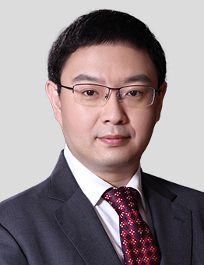
PRACTICE AREAS
MR. KANG SPECIALIZES IN PRIVATE EQUITY AND CAPITAL MARKET.

REPRESENTATIVE MATTERS AND CASES
Private Equity
- Represented KKR in its investments in Modern Dairy, the largest dairy farming company in China
- Represented Morgan Stanley in its investments in China Flooring Holding Company Limited, a leading flooring brand in china
- Represented KKR in its investments in Rundong Group, a leading luxury 4S dealership group in China
- Represented CMC in its investments in Ourgame, a leading online games company in China
- Represented CMC in its investments in IT companies
- Represented Morgan Stanley in its investments in hospitals
- Represented CDH in its investments in the agriculture sector
- Represented KKR in its investments in real estate
Capital Market
- Represented Morgan Stanley in its investment in Yongye International Inc, a NASDAQ-listed company
- Represented Morgan Stanley in its investment in China XD Plastics Company Limited, a NYSE-listed company
- Represented KKR in its investment in Qingdaohaier (600690), an A-share listed company
- Represented KKR in its investment in Shengnong Development (002299), an A-share listed company
- Represented the issuer in the IPO and listing on the Hong Kong Stock Exchange of RD Mobile (01365)
- Represented the sponsors in the IPO and listing on the NASDAQ of iDreamSky Technology (DSKY)
- Represented the issuer in the IPO and listing on the Hong Kong Stock Exchange of Logan PPT (03380)
- Represented the sponsors in the IPO and listing on the Hong Kong Stock Exchange of CH MODERN D (03380)
- Represented the issuer in the IPO and listing on the Hong Kong Stock Exchange of SIHUAN PHARM (00460)
Education
- China Renmin University, School of Law, LL.B
Professional Qualification
- Admitted to practice in the PRC
Professional Background
- Before joining Fangda Partners, Mr. Kang was a partner of Commerce & Finance law Offices and Haiwen Partners.

