SAM WANG  Partner·Shanghai  +86 21 6263 5819  sam.wang@fangdalaw.com | 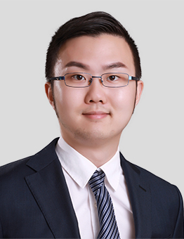
PRACTICE AREAS
SAM SPECIALIZES IN CORPORATE, M&A AND FINANCIAL REGULATIONS. HE ADVISES MANY LEADING COMPANIES AND FINANCIAL INSTITUTIONS ON THEIR INVESTMENTS AND ACTIVITIES IN THE PRC.

REPRESENTATIVE MATTERS AND CASES

- Represented JP Morgan in its securities joint venture project in the PRC
- Represented Credit Suisse in its securities joint venture project in the PRC
- Represented Nomura in its securities joint venture project in the PRC
- Represented DBS in its securities joint venture project in the PRC
- Provided regulatory advice to a number of international financial institutions (e.g., Morgan Stanley, Citadel, RBC)
- Designed the structure of the block chain + supply chain for Ant and prepared relevant transaction documents
- Represented Alibaba in its investment in Focus Media
- Represented Alibaba in its acquisition of Ele.me
- Represented Everbright in its investment in LifeTech
- Represented Ele.me in its merger with Baidu Waimai
- Represented Boyu in its investment in Chengjia
- Represented Coca Cola in its investment in Xiamen Cu Liang Wang
- Represented EDF in its power station project in the PRC
- Represented Tengyin in its A+ round equity finance
Education
- East China University of Political Science and Law, LL.B
- New York University School of Law, LL.M
Professional Qualification
- Admitted to practice in the PRC
Professional Background
- Before joining Fangda, Sam worked at a Magic Circle law firm for three years.

